Dungeon Positioning System

User Manual

Project Team: Elizabeth Dong, Gregory Purvine, Spencer Whyatt, Phillip Jones, Ray Cockerham

**User Manual**

To use the Dungeon Positioning System, the user must have the MySQL Connector JAR file included in the DPS build path. To start the system, the user must run DPS.java. The user must also download the Connector/J file from this site: <https://dev.mysql.com/downloads/connector/j/>

1. **Login Screen**

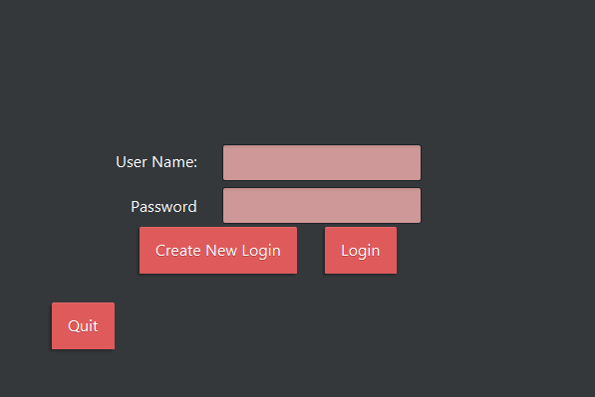

Upon running the application, the user must either enter an existing username and corresponding password and login, or create a new username and password, which may then be used to login.

**2) Create Account**

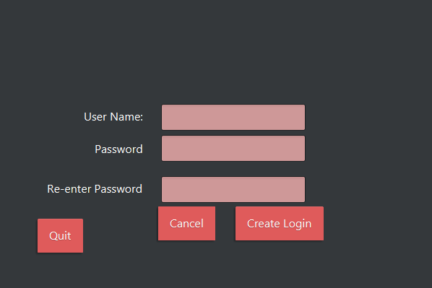

A secure password and unique username is necessary to create a new account.

**3) Home Screen**

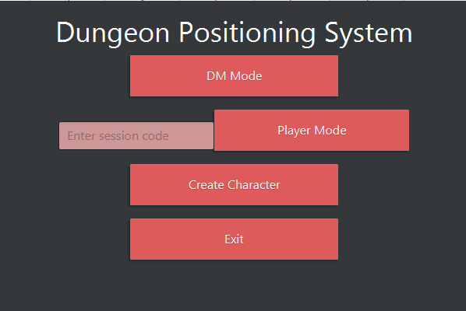

Here, the user can either enter into Dungeon Master mode, use a session code for an open session to join it in player mode, go to the character creation screen, or exit.

**4) Managing Sessions**

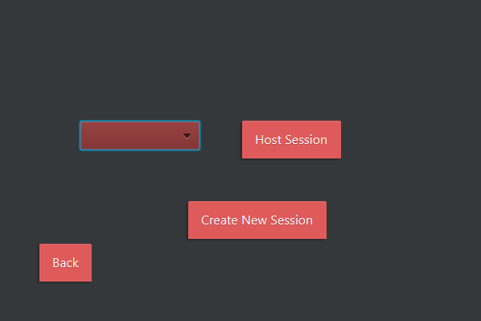

The Dungeon Master is given the open to either host an existing session or create a new session.

**5) Create Session**

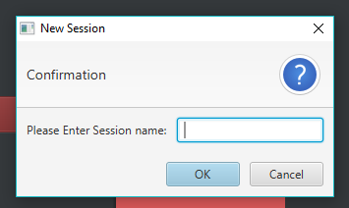

When creating a new session, the Dungeon Master is prompted to name the new session. A session code will be randomly generated and tied to that session after its creation.

**6) Dungeon Master Menu**

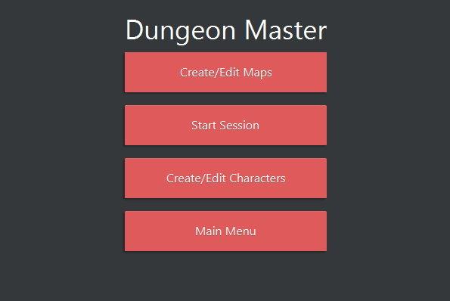

Here, the Dungeon Master can proceed to the map creation menu, start their session, go to the character creation menu, or return to the main menu.

**7)** **Map Creation**

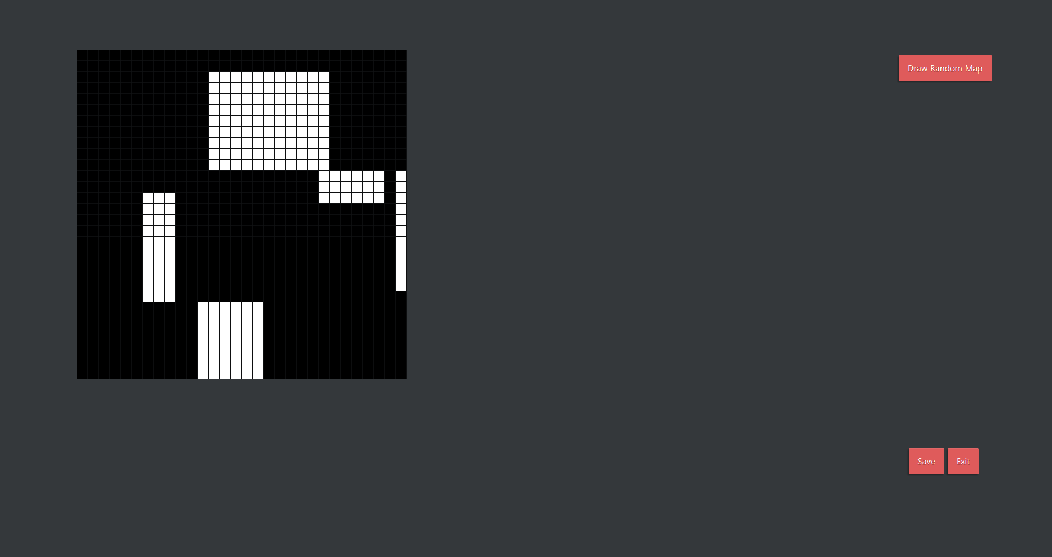

Here, the Dungeon Master can create and save a new randomly generated map.

**8)** **Game Screen**

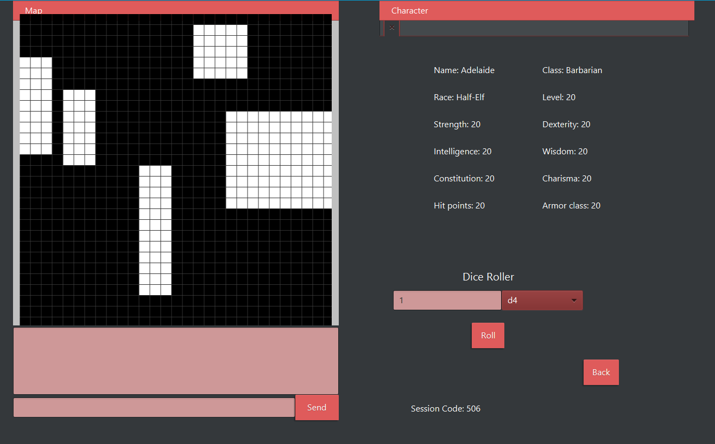

When the session is started, the Dungeon Master arrives at this screen. They can load a map using the map button on the menu bar, load and create character sheets using the character button on the menu bar, as well as use the text chat and dice roller. The dice roller can roll any number of D4, D6, D8, D10, D12, D20, or percentile die. The result would be the sum of these rolls displayed in the game log. The session code is located at the bottom right of this screen and can be shared to other players.

**9) Navigating the Player Menu**

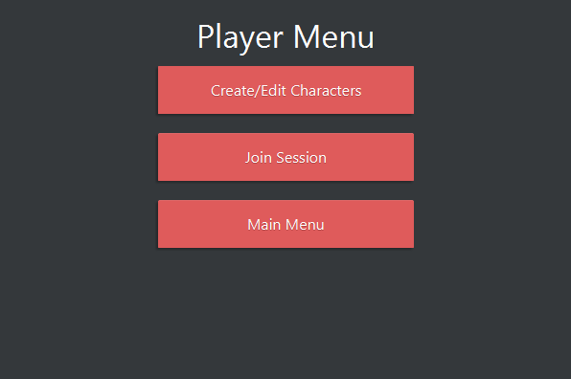

After entering the session code given by a Dungeon Master, the player will enter the player menu. From here, the player has the option to manage their character sheets, join the session, or return to the main menu.

**10) Managing Character Sheets**

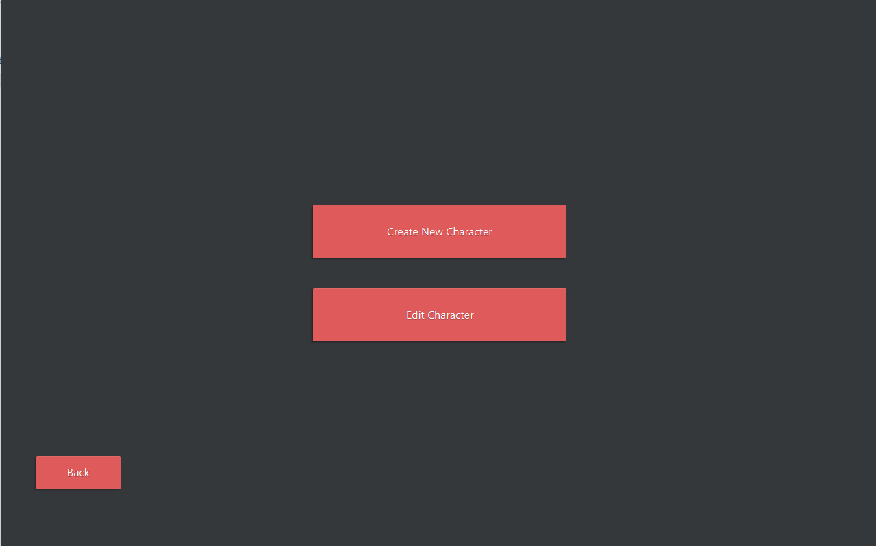

Here, the user can either edit an existing character sheet or create a new one.

**11) Create New Character**

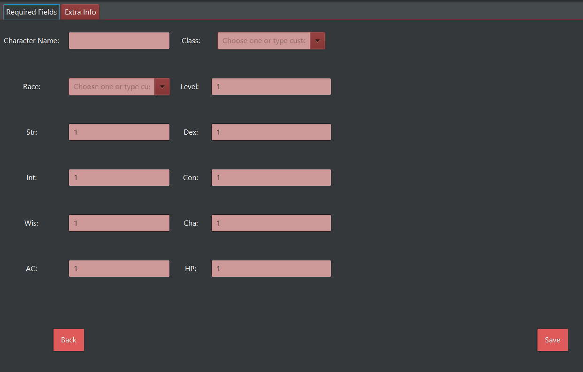

When creating new character sheets, the user will be sent to this menu where they are free to edit several basic stats of their character. After filling out their character sheets, the user may save it.

**13) Editing a Character Sheet**

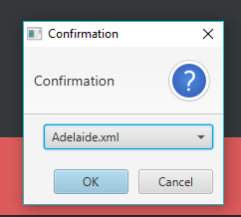

Players may edit an existing character sheet. They must use the drop down menu shown above to select which character sheet to edit. From here, they enter the character sheet menu again to edit their stats.

**14) Navigating the Game Screen as a Player**

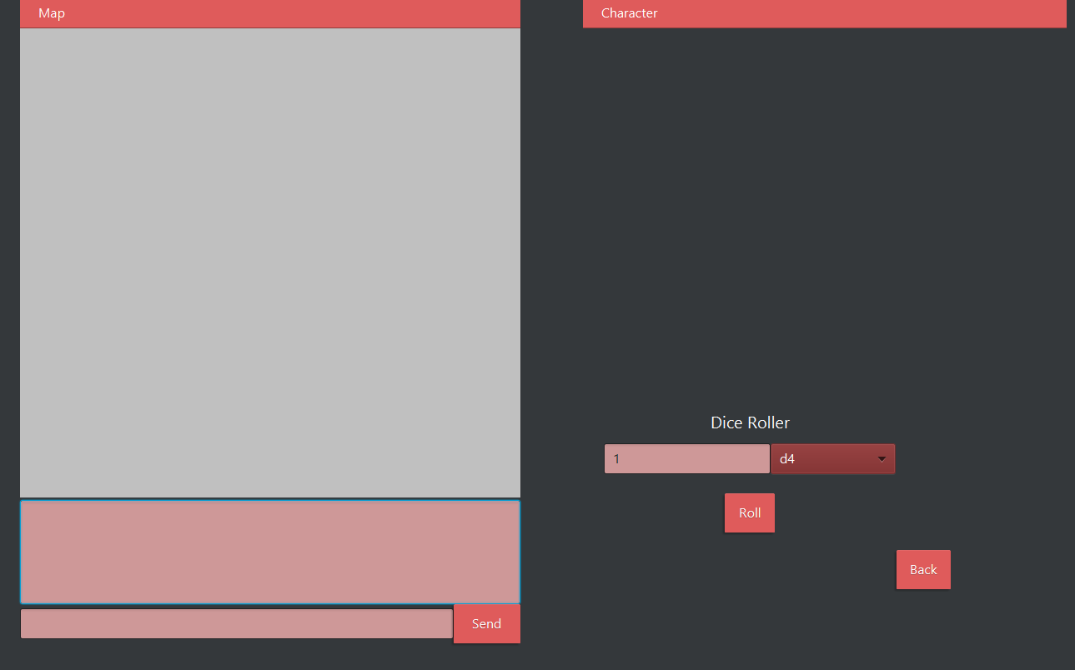

When the session is started, the player arrives at this screen. A map must be loaded in by the Dungeon Master. The player is able to load and create character sheets using the character button on the menu bar, as well as use the text chat and dice roller. The dice roller can roll any number of D4, D6, D8, D10, D12, D20, or percentile die. The result would be the sum of these rolls displayed in the game log.